
FOSHAN HANSE INDUSTRIAL CO., LTD
Add: NO.5 3rd road Jihua,chancheng district,Foshan,Guangdong
Tel: 0086-757-82725860; Fax: 0086-757-83610012 E-mail: export1@fshanse.com Web: www.hansetile.com
PROFORMA INVOICE
FROM: FOSHAN HANSE INDUSTRIAL CO., LTD
TEL:0086-13927724613,Sandy Liang
TO: MR. Rasaq Kuteyi PI NO.: HS20210816S
Date: 8-16-2021
Item No. | Image | Description | Color/Fini shed | SIZE/mm | Input | Output | Balance | Remark
342A | 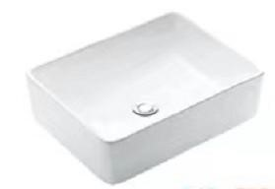 | ceramic sink without drain.without faucet | white | 480*370*130 | 94 | 0 | 94
2247A | 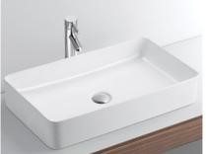 | ceramic sink without drain.without faucet | white | 610*340*110 | 59 | 0 | 59
2286 | 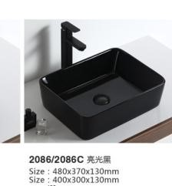 | ceramic sink without drain.without faucet | glossy  black | 480*370*130 | 10 | 00 | 10
2247 | 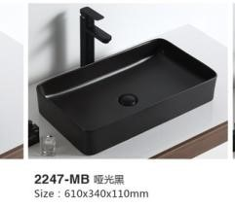 | ceramic sink without drain.without faucet | matt black | 610*340*110 | 10 | 0 | 10
HS-8016 | 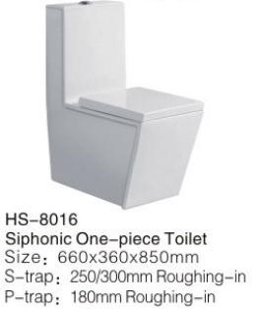 | Siphnoic One-piece toilet S-trap 300mm or P-trap  180mm Roughing-in-- Please select need P-trap or S-trap | white | 660*360*850 | 50 | 0 | 50
HS-8011 | 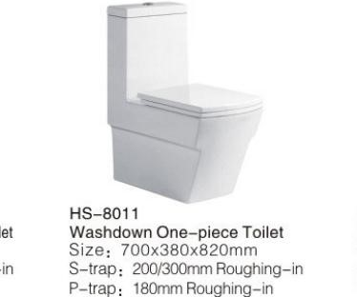 | Siphnoic One-piece toilet S-trap 300mm or P-trap  180mm Roughing-in-- Please select need P-trap or S-trap | white | 690*380*815 | 50 | 0 | 50
HS-028 | 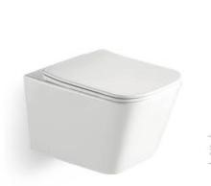 | Wall hanging toilet P-trap 180mm Roughing-in | white | 510*345*340 | 36 | 0 | 36
034-k6104 | 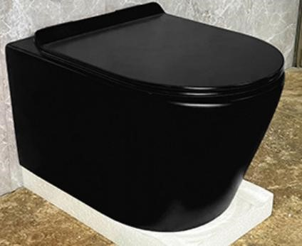 | Wall hanging toilet P-trap 180mm Roughing-in | glossy  black | 570*360*390 | 20 | 0 | 20

Item No. | Image | Description | Color/Fini shed | SIZE/mm | Input | Output | Balance | Remark
100BL | 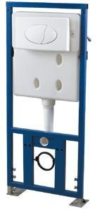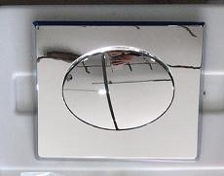 | Concealed cistern,with chromed buttom |  |  | 40 | 0 | 40
SG-580 | 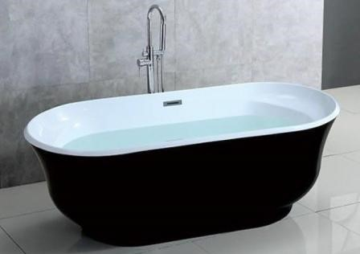 | Free standing acrylic bathtub,with water inlet and drain | white&black | 1700*800*620 | 10 | 0 | 10 | wooden crate  package
SG-541 | 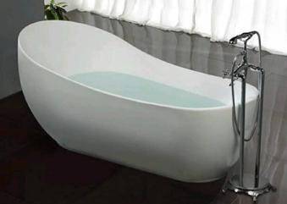 | Free standing acrylic bathtub,with drain | white | 1800*890*780 | 10 | 0 | 10 | wooden crate  package
SG-505 | 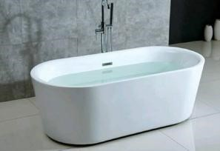 | Free standing acrylic bathtub,with water inlet and drain | white | 1700*810*600 | 10 | 0 | 10 | wooden crate  package
841033C | 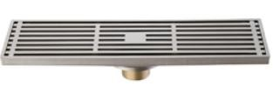 | Floor drain,copper | chromed | 80*300mm | 60 | 0 | 60
841039BN | 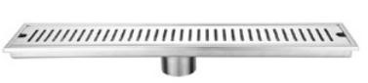 | Stainless steel floor drainer | Brushed Nickel | 100*600mm | 40 | 0 | 40
841026C | 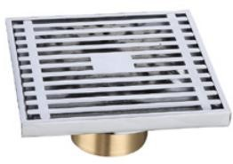 | Floor drain,copper | chromed | 100*100mm | 20 | 0 | 20
8410225C | 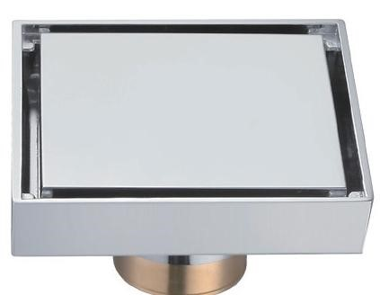 | Floor drain,copper | chromed | 100*100mm | 20 | 0 | 20
821009C | 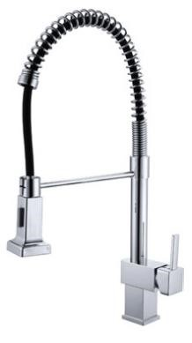 | Kitchen faucet | chormed |  | 20 | 0 | 20
811069C | 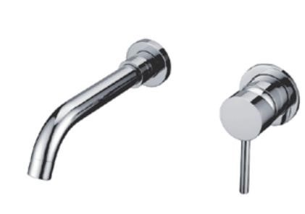 | Concealed faucet | chromed |  | 12 | 0 | 12
811076C | 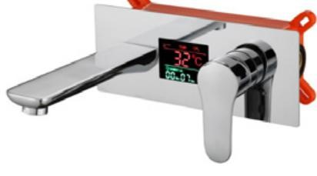 | Concealed faucet,with embedded box,copper,with display | chromed |  | 30 | 0 | 30

Item No. | Image | Description | Color/Fini shed | SIZE/mm | Input | Output | Balance | Remark
881115C | 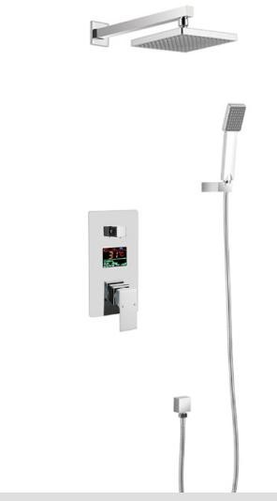 | Concealed shower set,with embedded box,copper,with display （I quoted long price  before so the price different) | chromed |  | 40 | 0 | 40
801306C | 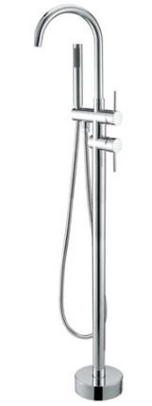 | Standing shower set, main material copper,and copper hand shower. | chromed |  | 19 | 0 | 19
821005C | 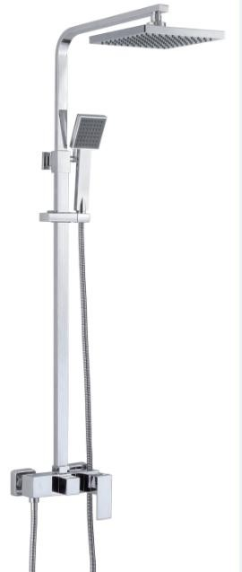 | two function shower set, copper body,SS304# tube,ABS top shower and hand shower | chromed |  | 80 | 0 | 80
8045 | 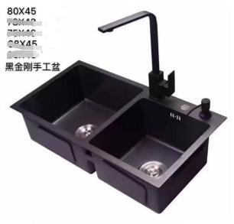 | Kitchen sink with drainer,material is SS304 ,size:  80*45cm | Black | 800*450 | 18 | 0 | 18
5040 | 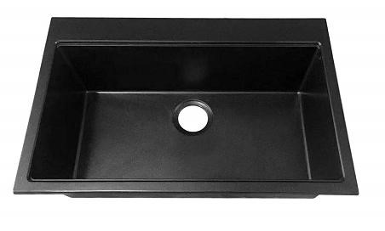 | Kitchen sink with drainer,material is SS304 ,size:  500*400mm | Black | 500*400 | 40 | 0 | 40
 | Total |  |  |  | 689 |  | 689
AFTER DISCOUNT
Remak:
1.Term of trade: EXW price.
- Payment: Alibaba. 30% deposit into our bank account after your order confirm,balance of before shippment.
- Packing: carton
- Delivery date:Around 25-30 working days after we received your depoist.
5.period of validity:30days

